CLIENT-SERVER ARCHITECT
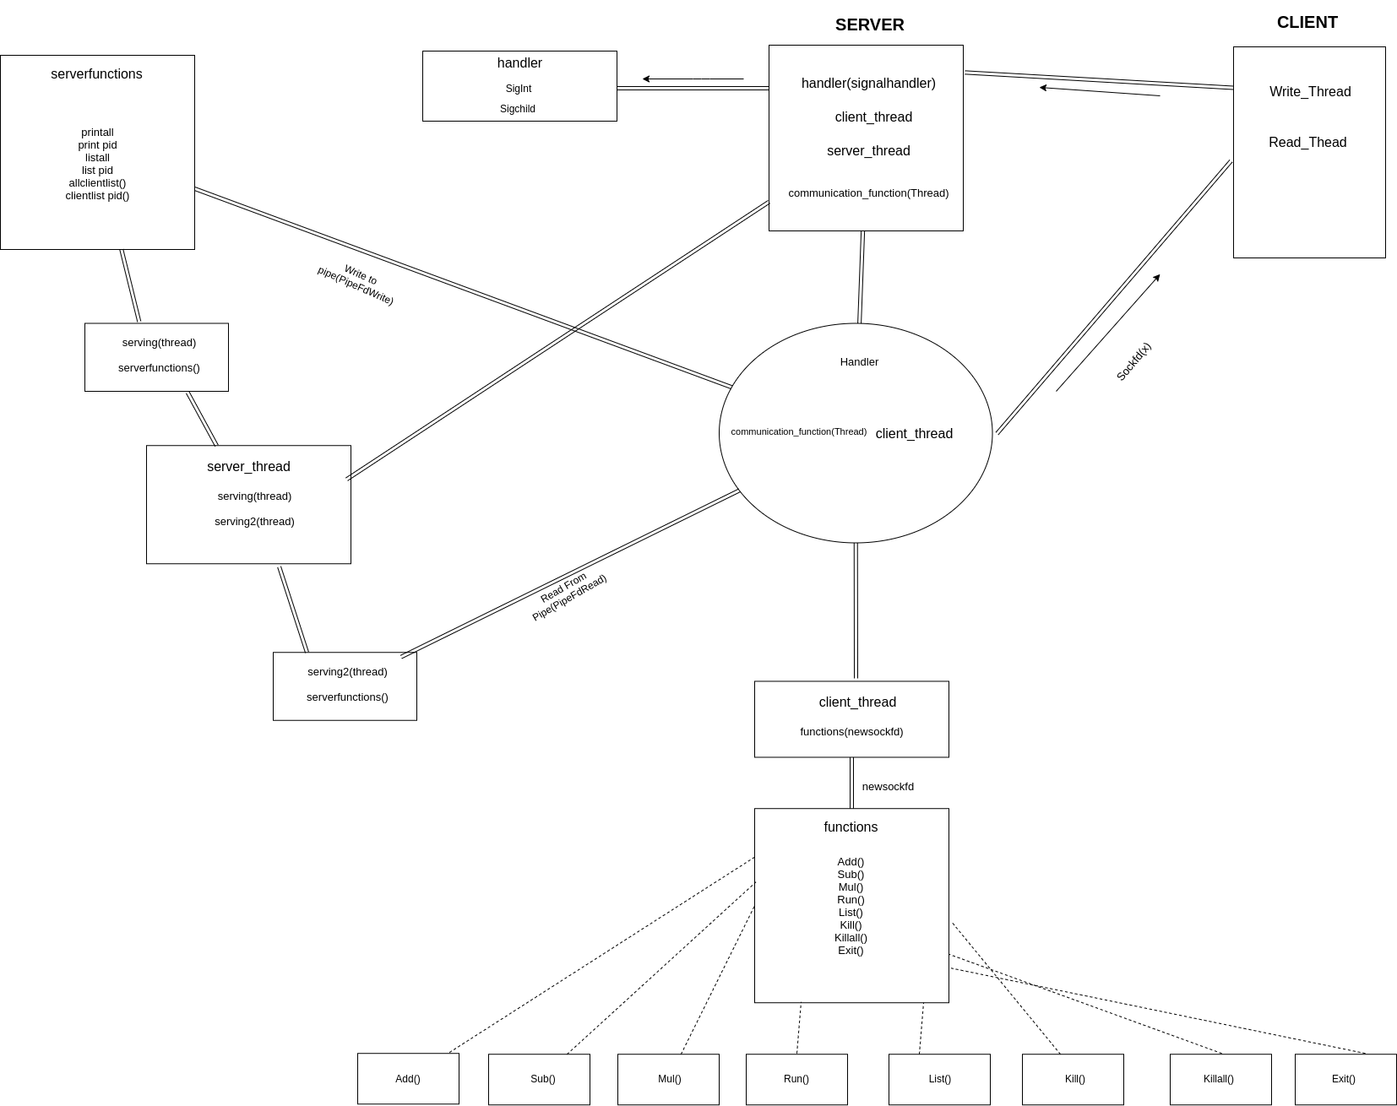

ABOUT

We have created a multi-threaded architect system.Here both server and clients can run multiple commands.Since it is multi-threaded architect, threads run simultaneously and share the same resource.In real world implementation(chat app, file transfer system,calculator) out computer on a network will either be clients or a server.Here 1 server is used to deal with all the clients(listen(sockfd, 5);//only 5 clients allowed to connect at a time rn)

Main file header for Socketing:
- #include<stdio.h>:contains declarations used in most C programs.
- #include<sys/type.h>:contains definitions of number of data types used in system calls
- #include<sys/socket.h>: header file for socket
- #include<netinet/in.h>:needed for internet domain address
- #include<stdlib.h>:library functions such as atoi

Basic Structure:
Server: Socket()---> Bind()--->Listen()--->accept()--->read()---->write()---->close().
Client:Socket()---->Connections()---->write()---->read()----->close()

- Int sockfd=socket(int_domain, int type, int protocol)
  - For int domain we will use AF_INET, which is just Internet protocol version 4.
  - Int type will be Sock_Stream which signifies we are using tcp protocol.we are sending data in stream.
  - Int protocol is 0 default for TCP protocol

- Int bind(int sockfd, const struct sockaddr*, socklent_t addrelen) :bind assigns the address given by addr(2nd param) to sockfd.
  - Struct sockaddr(sa_family sa_family;char sa_data[]):use to pass struct in addr to avoid compiling error.
  - Bind 0 on success and -1 on fail
- Int listen(int sockfd, int backlog):listens to the connection in the socket.backlog is the number of connection system can handle
- MsgSock=accept(sockfed,struct sockaddr*)&addr,addrlen):use to access the client so we can send msg to it
- Read: used to read the msg by client/server
- Write: used to write to client/server.
- Connections:accept waits for connection function.whenever read accept responds to it.

CLIENT SIDE

Our client side has 2 threads.
1- Write_Thead :This thread writes the read data into the socket so that it could be read by the server.
2- Read_Thread: Once we receive data back from the server ,it is read by this thread.

Both run in a simple while(1){} loop continuously within their respective threads waiting for read and write data.

Sockets in the client side allow the 2 way communications.

Functions Run by the Client
- Add:simple addition
- Sub:simple subtractions
- Mult:simple multiplication
- Div:simple division
- List:is used to print the details of all the processes the specific client is running.Details given by list are
  - PID
  - PPID
  - Name
  - Start time
  - End time
  - Elapsed time
*Time is not in seconds.Its in Hr.Min.Sec format.
- Kill pid/name: in order to kill a program you need to tell its name or pid.In case of name the first of the 2 programs is closed.
- Exit:when client writes exit , This happens:
  - All the process that the client opened are closed.If any process was already closed,msg is printed telling the the program has already been closed
  - The list is updated.Status is changed from active to not active.End time is written and elapsed time is calculated.
  - Client is killed.

SERVER SIDE

Server side is where most of the functioning is done.Once a connection is establish with the client.Our threads come to play. There are 3 threads in this side
- Client_handle:when our server side receives an input from the client.client handle caters it.This thread runs a function that tokenize the read string and checks if it matches any certain condition.If conditions are met our code runs the specific functions. These functions carry out the specific task and then write back to client with the result.You can see some condition in pic below.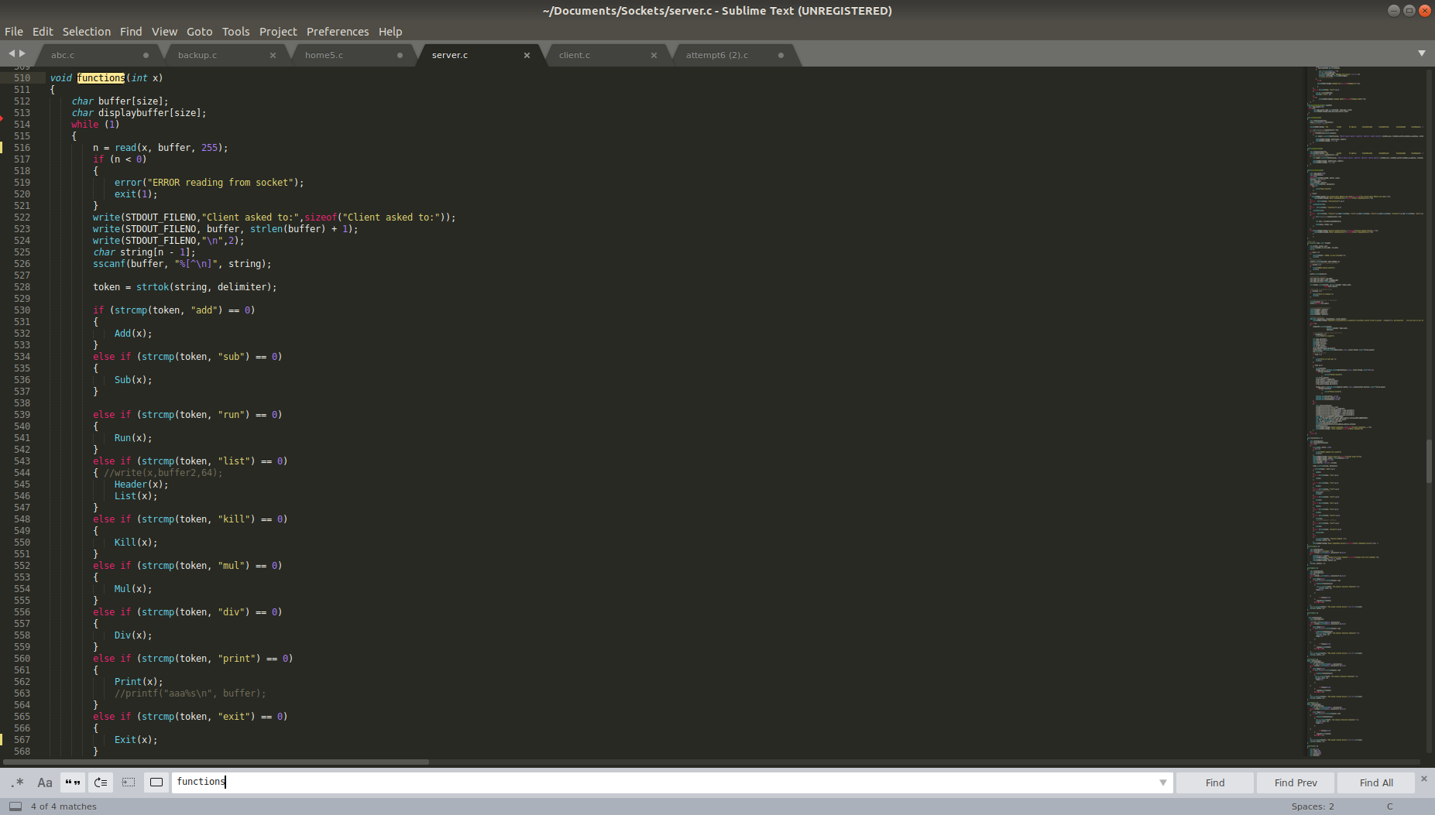
- Server_handle :Is a thread that is used to handle server commands. Which is a little complicated.Since it has to get data from the client handler as well.Basic logic is the same.Tokenize the string check which condition is meet and run that function.But if when we write list all or list pid. We need to get the list of processes from all the clients.So server_handle function writes List to the pipe which is connected to communication_function.server_handle itself has 2 threads.One is to run all basic functions.Other is to reading the data from pipe.when are a list arrives forms a client it reads it and prints it.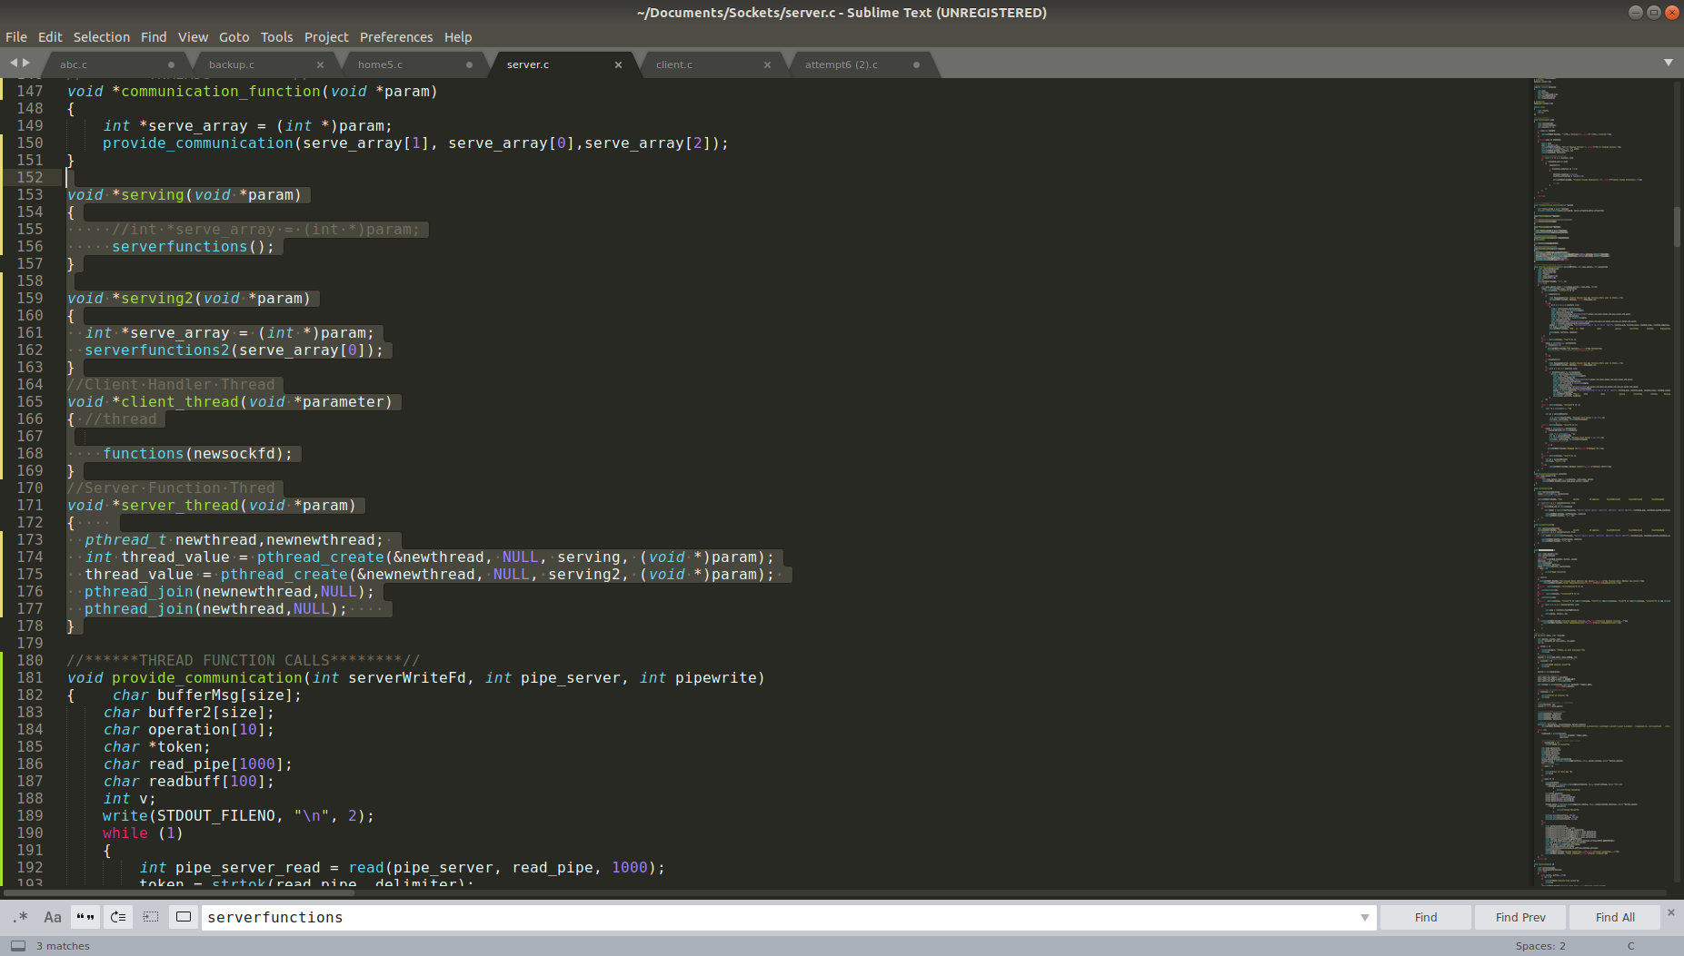
- Communication_functions:when server_handle thread writes on pipe.This Thread reads it.After reading it carries out the specific function.If its a list command it write it back to a pipe. Which is read by server_handler thread.If its a printall or printpid command.It will write the specific msg to the particular fd.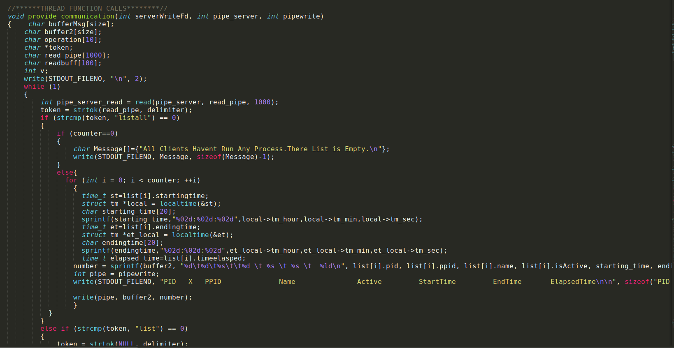

SIGNAL HANDLING

When our CSA is running.It could be our program is killed whether by the client via writing on client side or externally due to some issue or if the person using the server presses ctrc+c.
In order to keep track of such issues and handle them.I used SIG functions.
Whenever a program is closed externally.
- Server gets a msg “Program close externally”
- Pid of the program is given to tell which program is closed.
- Our list is updated.Active status of program is set to 0.

When a user presses ctrl+c the server sides tell u have tried to press ctrl+c.Our server isn't closed.

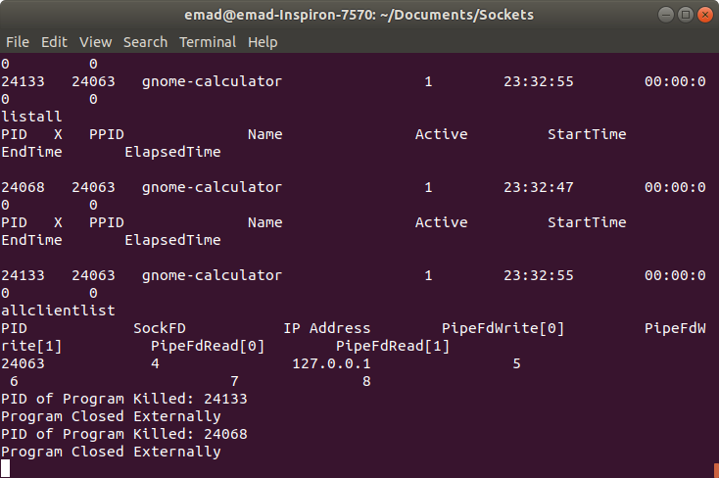

ISSUES:
-You cannot run multiple commands at once.Eg add 2 2; sub 3 3 ; won't work.Although run gedit firefox will run both.
- When dealing with characters in Addition if u write 2 + a , the result from server will be 2.The Server will send a msg to client telling, “ You have input an alphabet” but the output given is incorrect as 2 +a isn't compatible.
-Server is not parallel
-Only 5 clients can be connected.we can change it in code, but it's a limitation, what if the 6th client wanted to connect? We can't be able to cater to it until one disconnects.
-Max size of any list is 1000 bytes.It can be increased in code,but again if while running size is increased the system won't be able to handle it.
- List printing, although the list shows the correct data,and number of processes.The heading is printed multiple times.
- In list printing(client side),it happened to me a few times where not all processes were shown,I had to run the list command again.
- elapsed time formating is not correct

HOW TO RUN CODE

To run Server:
- Goto specific file directory
- Type:gcc server.c -o server -lpthread
- ./server 9000(or any value above 9000)
- Once it connects with the client it will show.
”Client Connected”
“Enter Command”
5.Enter command you wish to run

To run Client:
- Goto specific file directory
- Type:gcc client.c -o client -lpthread
- Type:./client 127.0.0.1(loopback ip if in same pc) 9000(portno same as server)
- Once connected with server it will show on screen,Enter Command:
- Write the command.

Commands for CLIENT SIDE:
- Run program name. Eg run gnome-calculator
- Add numbers. Eg add 2 2 3
- Sub numbers. Eg sub 2 2 3
- Mul numbers. Eg mul 2 2 3
- Div numbers.Eg div 2 3 4
- List Eg list
- Kill pid/name eg kill 123 or kill zoom
- Exit eg exit
- Killall eg killall

Commands for Server SIDE:
- List pid.Eg list 213
- Listall Eg listall
- Printall msg Eg printall Hello
- Print pid msg eg print 123 Hello
- Allclientlist eg allclientlist
- Clientlist pid eg clientlist 124

*Commands are not case sensitive ADD 2 2 will also work

